**TRF ROBOSOFT IMAGE PROCESSING TASK-2**

**GROUP 3-**

1. **Manali Teke**
2. **Tanvi Wakade**

**3) Jayant Meshram**

# Task- OPTICAL FLOW

## 11th Sept 2020

We were given task related to Optical flow. The aim is to determine the direction of moving object while the camera moves. In the first meet we decided to do individual research and then finalize the approach.

## 12th September 2020 to 13th September 2020

Read about Optical Flow and various methods in optical flow- Sparse optical flow (Lucas-Kanade optical flow based on Shi-Tomasi Algorithm for detecting corners) and Dense optical flow (based on Gunner Farneback’s Algorithm). Also read about Meanshift and Camshift methods to track objects in video.

**14th September 2020 – 15th September 2020**

We were finding it difficult to directly implement object tracking for moving camera, so we decided to go step-by-step from scratch by object tracking in stationery camera first. Implemented Lucas-Kanade optical flow method to determine the direction of moving object and draw tracks of motion for stationary camera.

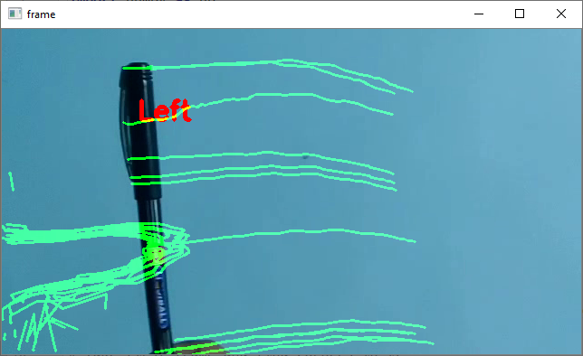

1. Output of Lucas-Kanade Optical flow method

**16th September 2020**

Presented output of the previous code. Some improvements suggested and further task given by mentors as follows:

1. Object tracking lines are too dense. Improve code such that previous lines disappear after object moves.
2. To implement dense optical flow and show different hue colour for objects moving in different directions.

**17th September 2020 – 20th September 2020**

Read more about Dense optical flow, Gunnar-Farneback algorithm. And tried to implement the code. Also made suggested improvements in the previous code. The permanent lines were because we were adding old frame on new frame. So, we directly operated on current frame without using temp frame.

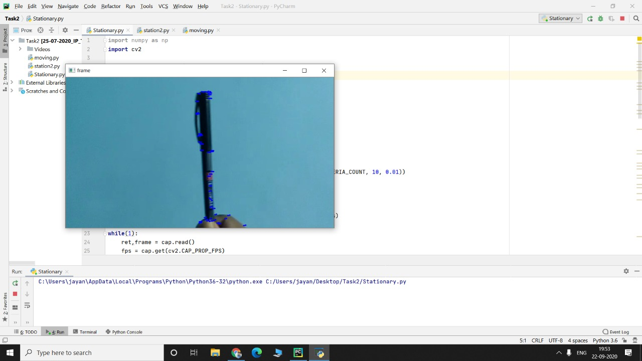

1. Output-1 after improvements in previous code of Lucas-Kanade optical flow.

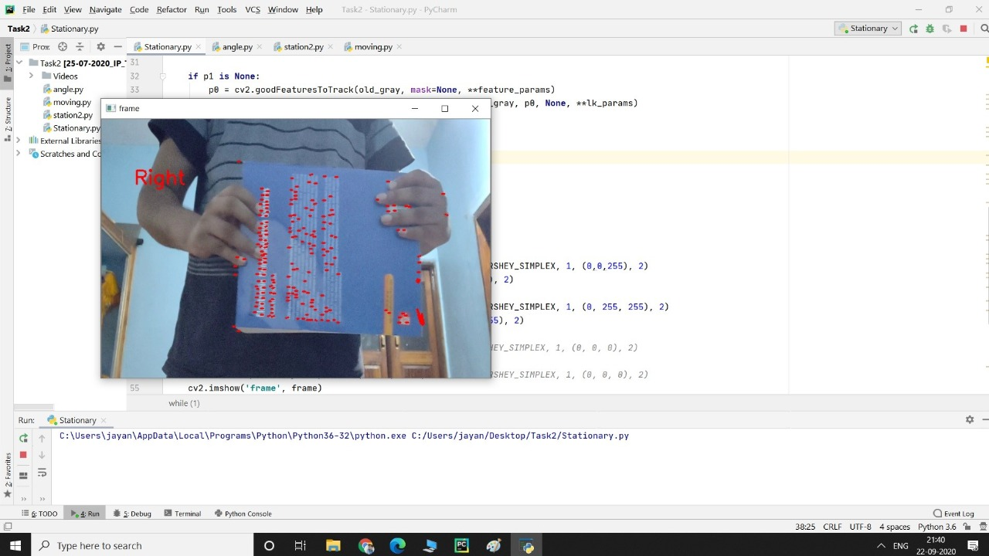

1. Output-2 after improvements in previous code of Lucas-Kanade optical flow.

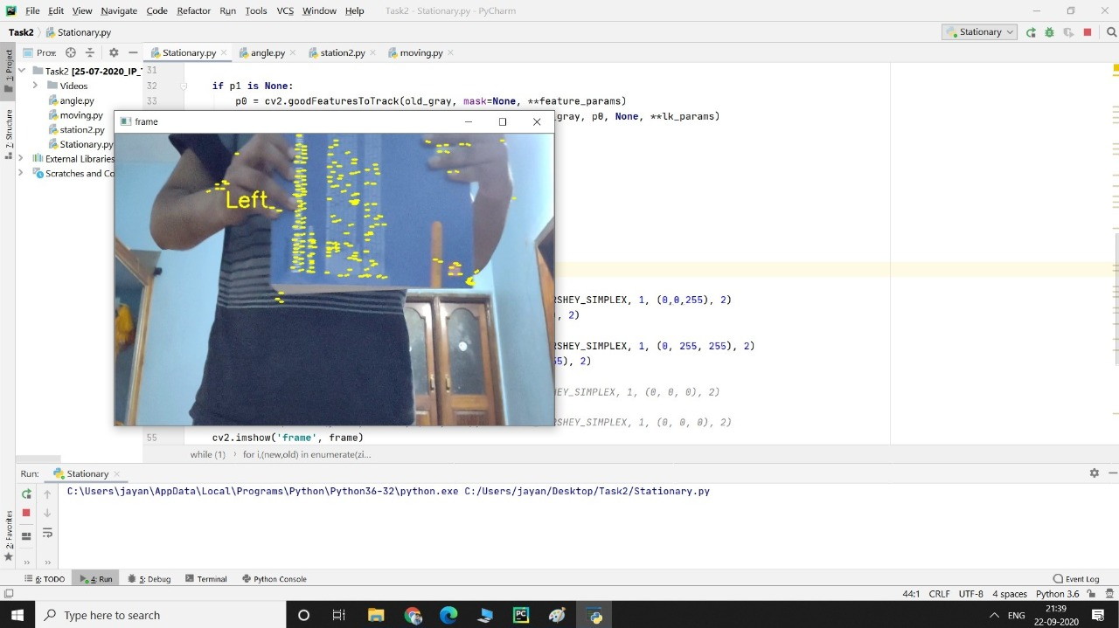

1. Output-3 after improvements in previous code of Lucas-Kanade optical flow.

**21st September 2020**

Implemented dense optical flow where the direction of the moving object is visualized by hue.

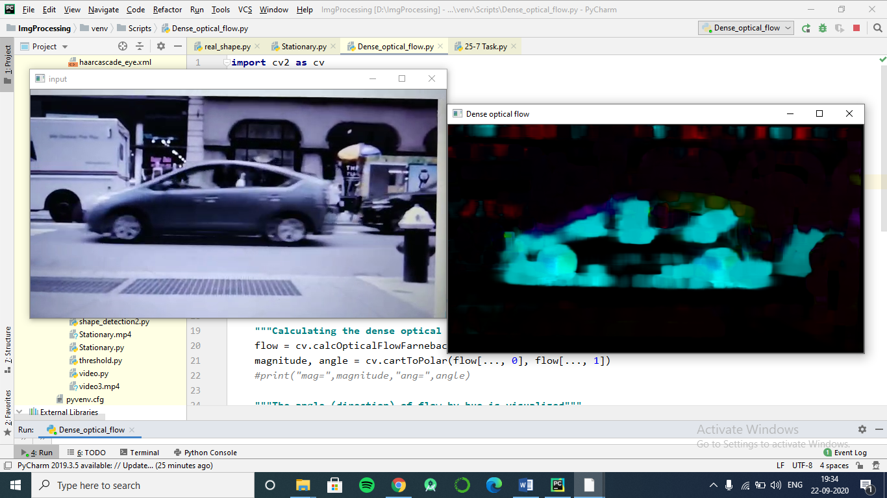

1. Output of Dense-optical flow

**Task completion timeline**

**15th Sept 2020 – Successfully implemented Lucas-Kanade optical flow method to predict direction and show tracks of moving objects.**

**21st September 2020 - Successfully implemented Dense optical flow method .**

**22nd September 2020- Successfully implemented suggested improvements in the previous code.**

---------------------------------------------------------------------------------------------------------------------------------------